# STEPS TO SETUP XML2CSV

1. Install Python (This application was built in the version 3.8.1):

<https://www.python.org/downloads/>

1. Download the GITHUB repository maintained for this application, into your local system:

<https://github.com/vikrantdeshpande09876/XML_to_CSV_Rep>

1. Open Command Prompt (cmd) and navigate to the directory where you downloaded the above repository. For example:

*cd C:\Users\mypc\Desktop\XML_to_CSV*

1. Now create a virtual environment for creating a copy of your system-wide Python interpreter:

*python -m venv myvirtualenv*

1. Activate this virtual environment. You need not perform step#4 each time for execution:

*myvirtualenv\Scripts\activate*

1. Install flask:

*pip install flask*

1. Install the application-specific dependencies by executing:

*pip install -r requirements.txt*

1. Set the starting point for running this Flask application as *run.py:*

*set flask_app=run.py*

1. Execute the application:

*flask run*

1. Open a web-browser and navigate to the URL mentioned in the cmd output from above command. For example <http://127.0.0.1:5000/> which is the same as <http://localhost:5000/>

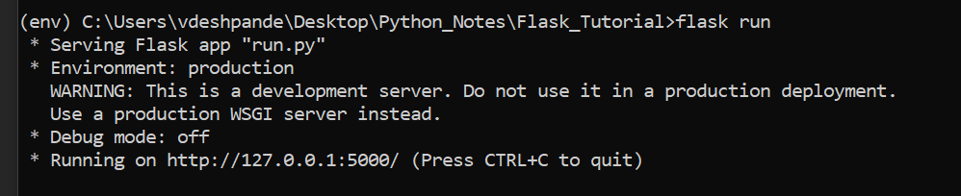

1. Currently the application is hardcoded to accept ‘v’ and ‘v’ for logging in.